Lead-Sheets Application

## Instructions

Instructions for “Lead-Sheets Application”

**Please read and follow all the instructions for a proper use of the application!**

## Pre-requisites:

This application has 2 possible case scenarios, depending on the Trial Balance provided.

Case 1: We import a regular Trial Balance

## If the Trial Balance to be imported is not generated by the Trial Balance Application, the box in the next image should be checked:

## Consequently, the Trial Balance template that we have to load must have the following header:

|  |  |  |  |  |  |  |  |
| --- | --- | --- | --- | --- | --- | --- | --- |
| Account | Description | OB | DM | CM | CB | LS | Type |
| 411 | Clients | 2.341 | 34.325 | 5.353 | 31.313 | Capital | BS/PL |

## *Type must be BS or PL.

Case 2: We have the Trial Balance generated by the Trial Balance Application

In this case, the box should be checked, and no further formatting is needed. The Trial Balance generated by the application can be imported as is.

## Instructions:

1. After connecting to the platform, go to **Leadsheets**:

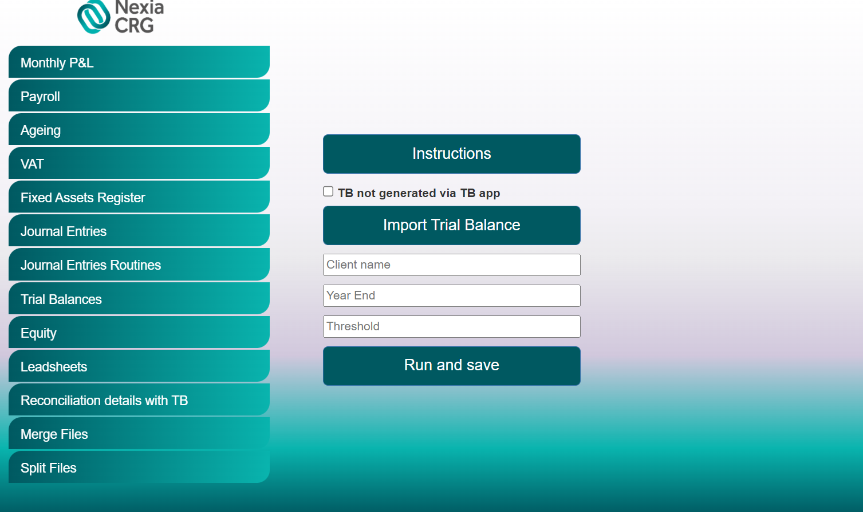

1. Enter the client’s name and the period end (MM/DD/YYYY) of the audit (Year End).
2. Click “Import Trial Balance” and select the Trial Balance template (with the header above or directly generated by the app).
3. Click “Run and save”. Once clicking that, the robot will ask the desired saving location, will process your request and download the test/file.
4. Finally, you should obtain an archive document named “LS” + Client name.

For any issues, questions and/ or suggestions, please contact:

Cristian Iordache, [cristian.iordache@ro.gt.com](mailto:cristian.iordache@ro.gt.com)

Bogdan Constantinescu, [bogdan.constantinescu@ro.gt.com](mailto:bogdan.constantinescu@ro.gt.com)